Chapter 10 Plate tectonics
extra worksheet 2:Plate tectonics
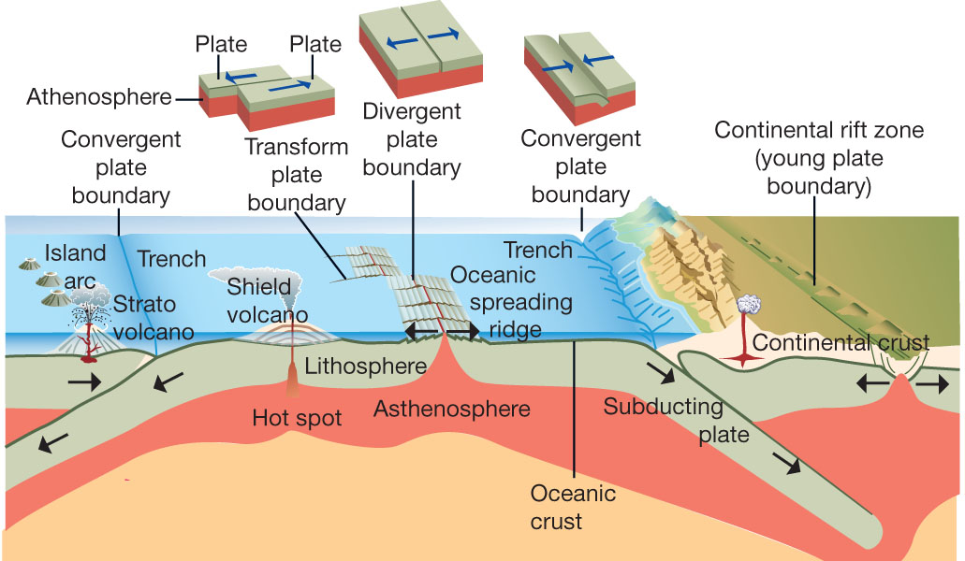
1 Describe where seafloor spreading is shown in the diagram above.

2 Explain what ‘subducting plate’ refers to and why the trench formed.

3 Explain why the island arc occurs in Figure 1.

4 Explain why the crust subducted on both the right-hand and left-hand sides as shown in Figure 1.

